B22228

Q:

For the system as modelled in tutorial, single line diagram given below, comment on the current contributions of the two sources during fault condition in table 2.

**Table 1: Given Data**

|  |  |
| --- | --- |
| Fault Type | ABC |
| Fault Location | 10 km from source |
| Fault Resistance $R_{f}$ | 0.005 Ω |

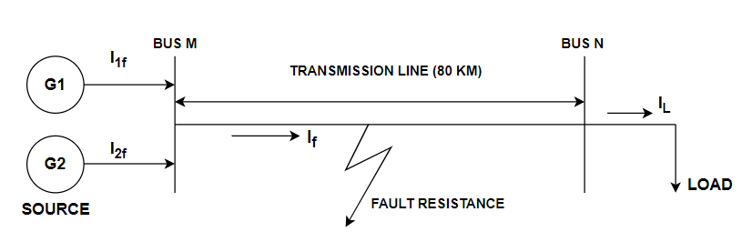

**Table 2: During Fault (Fill the blank rows below).**

|  |  |  |
| --- | --- | --- |
| **Source** | **Generator ($G_{1}$)** | **Generator ($G_{2}$)** |
| Source Resistance | $R_{s1}$ = 0.8929 Ω | $R_{s2}$ = 10 Ω |
| Fault current $I_{1f}$ |  |  |
| Fault current $I_{2f}$ |  |  |
| Source reactance ( $L)$ | $L_{G1}$ =0.01658 H | $L_{G2}$ =0.01658 H |

**Briefly comment on the following question:**

What is the effect of change in the fault location from source terminal Bus M to the fault location defined in the Table 1?